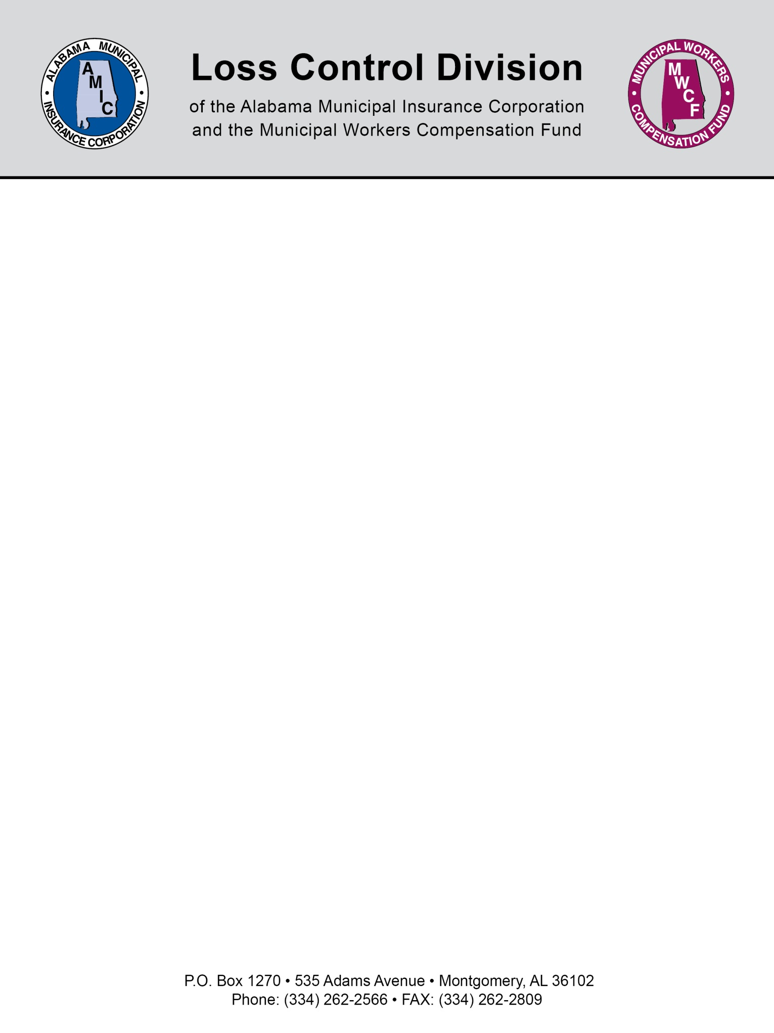

We encourage you to check the following information on the Driver License Division page on the Alabama Law Enforcement Agency’s website, www.alea.gov, for the most current information regarding the Driver License Point System.

Driver License Point System
Offense | Point Count
Speeding (1 to 25mph over speed limit) | 2
Speeding (26 or more mph over speed limit) | 5
Reckless driving or reckless endangerment involving operating a motor vehicle | 6
Failure to yield right of way | 5
Passing stopped school bus | 5
Wrong side of the road/Illegal passing | 4
Following too closely | 3
Disregarding traffic control device (stop sign, traffic light, etc.) | 3
All other moving violations | 2
Inability to control vehicle | 2
Improper lane | 2
Drinking alcohol while operating a vehicle | 2
Admin per se | 6
Improper operation of motorcycle | 2
Fail to obey construction/maintenance zone markers/flagman/police officer/restricted lane | 3
Emergency vehicles | 2
Fail to signal/use incorrect turn signal | 2
Making improper turn | 2
Coasting | 2
Unsafe operation | 2
Any conviction which resulted from a charge that involved the drinking of alcoholic beverages and the driving of a motor vehicle but did not require mandatory revocation of the driver license | 6

The following schedule is used to determine the length of a suspension period
- 12-14 points in a 2-year period 60 days
- 15-17 points in a 2-year period 90 days
- 18-20 points in a 2-year period 120 days
- 21-23 points in a 2-year period 180 days
- 24 and above points in a 2-year period 365 days
After a traffic conviction is 2 years old, it loses its point count for suspension purposes but remains on a driver's record.

2 serious offense tickets in a 3 year period--60 day disqualification
3 serious offense tickets in a 3 year period--120 day disqualification

Serious offenses:
- Excessive speed- 15 mph over posted speed limit
- Reckless driving
- Improper or erratic lane change
- Following too closely
- Any violation in connection with a fatal accident
- Driving a cmv w/o obtaining a cdl
- Driving a cmv w/o cdl in possession(may be dismissed if proof provided in court)
- Driving a cmv w/o proper class and/or endorsements
- Violating a State or local law or ordinance on motor vehicle traffic control restricting or prohibiting the use of a hand-held mobile phone while driving a CMV.

CDL Disqualification:
Major offenses for cdl holders while in a cmv
- Being under influence of alcohol
- Being under influence of controlled substance
- Having concentration of .04 or greater while operating cmv
- Refusing to take alcohol test
- Leaving the scene of accident
- Using cmv to commit felony
- Driving cmv while cancelled/suspended/revoked/disqualified
- Causing fatality through negligent operation of a cmv
- Using cmv in the commission of felony/production of controlled substance

Rail road crossing disqualifications:
Driver not required to always stop:
- But fails to slow down and check the tracks are clear
- But fails to stop before reaching the crossing if the tracks are not clear
Driver always required to stop:
- But fails to stop before driving onto the crossing
The driver:
- Fails to have sufficient space to drive completely through the crossing w/o stopping
- Fails to obey a traffic control device or the directions of an enforcement officer at the crossing
- Fails to negotiate a crossing because of insufficient undercarriage clearance
Violating out of service orders:
- Violating a driver or vehicle out-of-service order while transporting nonhazardous materials
- Violating a driver or vehicle out-of-service order while transporting hazardous materials requiring placards

NOTE: This document is not intended to be legal advice. It does not identify all the issues surrounding the particular topic. Public agencies are encouraged to review their procedures with an expert or an attorney who is knowledgeable about the topic. Reliance on this information is at the sole risk of the user.

Rev 1/2017

